MPTK Plug-ins system

SUMMARY

Read this document to learn how to build plug-in for Blocks and Atoms in MPTK

LAYOUT
1.Introduction 2
2.The block factory 6
3.The atom factory 9
4.Concrete implementation 11
5.Help, contact and forums 13
6.Credits 13

- Introduction

Basic
A dynamic-link library (DLL) is a module that contains functions and data that can be used by another module (application or DLL). In Linux/UNIX, the same concept is implemented in shared object (.so or .dll) files. From now on, I use the term shared libraries to refer dll and so files used by MPTK. The shared library presents several advantages:
- Create modular applications
- Reduce memory overhead when several applications use the same functionality at the same time, because although each application gets its own copy of the data, they can share the code.

Fundamentals - shared libraries.
Creating, Linking and Compiling the DLL or SO:
- Write code for the DLL or SO. Identify the functions or variables that are to be available for the calling process.
- Compile the source code into an object file.
- Link that object file into either a DLL or SO with required library.
Accessing the DLL or SO from a Calling Process:
- Load the DLL or SO.
- Get a pointer to the exported function or variable.
- Utilize the exported function or variable.
- Close the library.

Scheme used for MPTK plugin system
This scheme show the architecture of MPTK plugin system:
- The User interface layer are statically linked to libmptk shared libary
- When call to set up the environment, MP_Dll_Manager of libmptk try to load all the Blocks/Atoms plugin contain in a specified directory.
- The successfully loaded plugins register themselves in the MP_Block_Factory or in the Mp_Atom_Factory depending on their type.
- Once the Blocks/Atoms registered in the relative factory, libmptk can use their functionalities.
Note that libmptk, the MPTK shared library is not static because of Dynamic Linking for MinGW under MS-Windows:
shared libraries under MS-Windows have one limitation: they can't have even one undefined symbol. This means at the time you create a shared library, you must link it against other shared libraries in order to get all the undefined symbols from the object files resolved in some way.
In most cases this is fine. A good design expects that if a shared library a depends on the shared library b, then b doesn't require a. This is true when you create a library in which you offer some functionality for different projects to use.
Now, We want to create a plug-ins system for MPTK. Plug-ins are very similar to shared libraries. In fact, under Unix like platform (Linux and others) you create shared libraries and you call them plug-ins. With a shared library under MS-Windows this doesn't work too well since it can't have undefined symbols and by default a shared library under MS-Windows doesn't link back to your application (EXE). A plug-in is expected to link against the main application.

The chosen solution was to create some very small applications (User Interface Layer) which only purpose is to link against the larger shared library libmptk which actually is the real application. This shared library can export all the symbols we need in the Block/Atoms plug-ins.

Static link

Matlab Interface
Command line
GUI
User Interface Layer (Stater)
ATOMS SHARED LIBRARY
DLL
BLOCK SHARED LIBRARY
DLL
MPTK SHARED LIBRARY: libmptk DLL
MP_Dll_Manager
MP_Atom_Factory
MP_Block_Factory
Load/Close
Register
Register

Once the library loaded, the registry symbol is called in each plug-in, in order to call the registry method which has to register the Atom/Block plug-in into the corresponding factory.

Sequence diagram

Register Atoms/Blocks in the factories
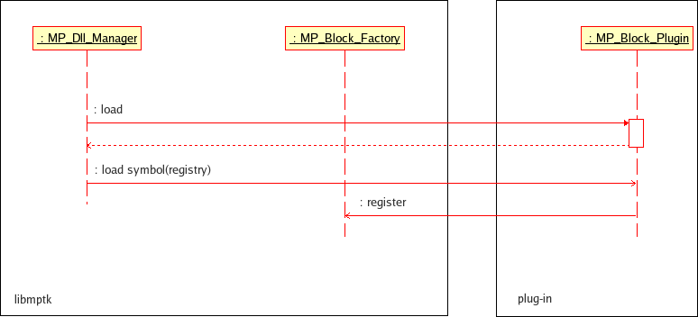
The sequence is the same for Atoms and Blocks

Usage of Atoms/Blocks factories during MP decomposition
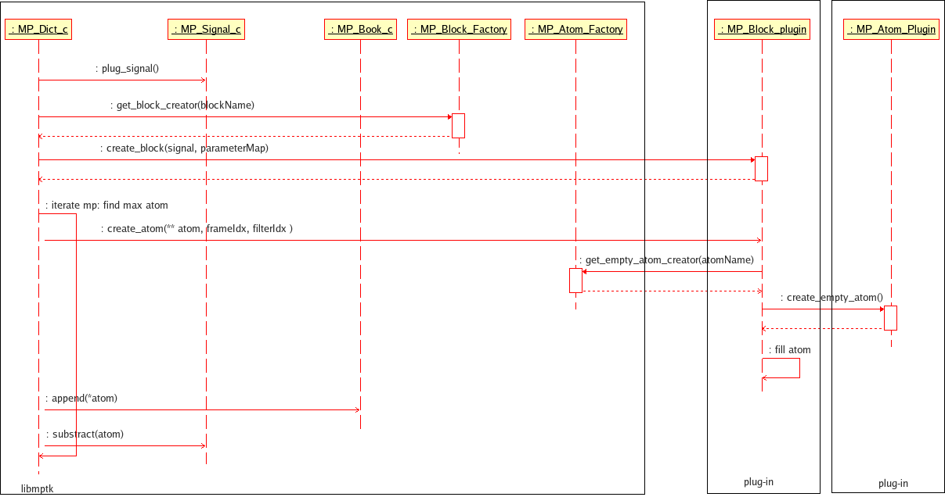

Usage of Atoms factory during recomposition
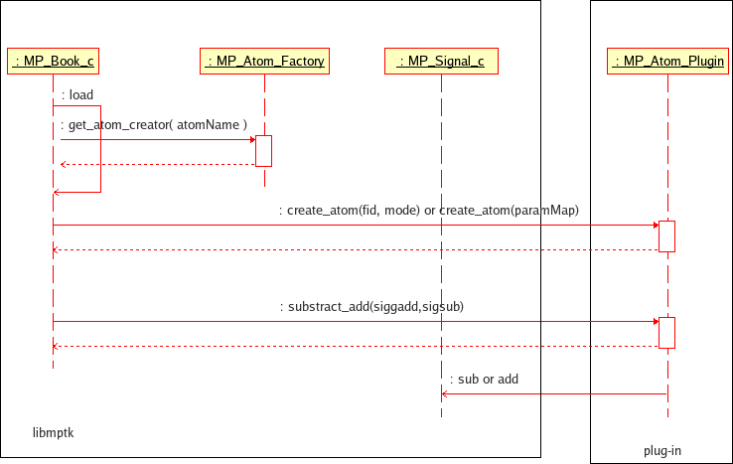

Differences between dll and so: MP_Dll_Manager class
There are many differences in the way shared libraries are created, exported and used.
A shared library can define two kinds of functions: exported and internal. The exported functions are intended to be called by other modules, as well as from within the shared library where they are defined. Internal functions are typically intended to be called only from within the shared library where they are defined. Although a shared library can export data, its data is generally used only by its functions. However, there is nothing to prevent another module from reading or writing that address.
But in the case of Linux/Unix, no special export statement needs to be added to the code to indicate exportable symbols, since all symbols are available to an interrogating process (the process which loads the SO/DLL).

Operation | Unix/Linux | Windows
Export symbols in src file | No export symbol required. | __declspec( dllexport )
Header file | #include <dlfcn.h> | #include <windows.h>
Loading the shared library | void* dlopen( const char *pathname, int mode ); | HINSTANCE LoadLibrary( LPCTSTR lpLibFileName );
Runtime access of functions | void* dlsym( void* handle, const char *name); | GetProcAddress( HMODULE hModule, LPCSTR lpProcName);
Closing the shared library | int dlclose( void *handle ); | BOOL FreeLibrary( HMODULE hLibModule );

Files implementation:
- dll.h: methods declaration for all platform
- dll_elf.cpp : specific code for Linux and Mac OSX platform
- dll_win32.cpp: specific code for Windows platform
The selection of code part for the concerned platform is done via #ifdef preprocessing directives.
- The block factory

Principle
The block factory class has to have an unique instance in order to register all the Blocks plug-ins.
The block factory class should provide five services to the MPTK core library:
- A pointer on the Blocks Factory Method contained in the block plug-in to create a specified block.
- A pointer on a function that fill a Parameter map with the type of mandatory parameters for a specified block.
- A pointer on a function that fill a Parameter map with the description of mandatory parameters for a specified block.
- A pointer on a function that fill a Parameter map with the default value of mandatory parameters for a specified block.
- A list of all the block currently registered in the block factory.
- A method to register a block in the block factory

MP_Block_Factory class specification

MP_Block_Factory scheme
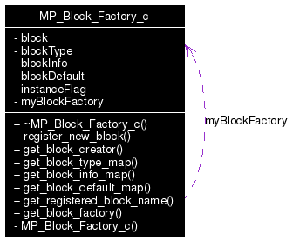

Class method specifications
Getter for block factory singleton:
Method to get an unique instance of MP_Block_Factory_c.
MP_Block_Factory_c * MP_Block_Factory_c::get_block_factory () [static]

Getter for Factory Method block creator :
Accessor method to obtain the address of a factory method to create a block from a parameter map.
MP_Block_c*(* MP_Block_Factory_c::get_block_creator (const char * blockName)
Parameters:
blockName : name of the block to create
Returns:
a pointer on a Factory Method able to create the block identified by blockName with a MP_Signal_c *s, map<string, string, mp_ltstring> *paramMap , NULL if the block isn't registered

Getter for block_default_map method:
Method to fill a parameter default map for blockName.
void(* MP_Block_Factory_c::get_block_default_map (const char * blockName)
Parameters:
blockName : name of the block for which the map has to be fill
Returns:
a pointer on a method able to fill the given map< string, string, mp_ltstring> * parameterMapDefault

Getter for block_info_map method:
Method to fill a parameter info map for blockName.
void(* MP_Block_Factory_c::get_block_info_map (const char * blockName)
Parameters:
blockName : name of the block for which the map has to be fill
Returns:
a pointer on a method able to fill the given map< string, string, mp_ltstring> * parameterMapInfo
Getter for block_type_map method:
Method to fill a parameter type map for blockName.
void(* MP_Block_Factory_c::get_block_type_map (const char * blockName)
Parameters:
blockName : name of the block for which the map has to be fill
Returns:
a pointer on a method able to fill the given map< string, string, mp_ltstring> * parameterMapType

Getter for registered_block_name:
Method to fill a vector with the name of all the blocks registered in the block factory.
void MP_Block_Factory_c::get_registered_block_name (vector< string > * nameVector)
Parameters:
nameVector : pointer on the vector which have to be fill with the name of blocks

Method to register new block in the factory:
Method to register a new block with blockName in the various hash table of block factory.
void MP_Block_Factory_c::register_new_block (const char * blockName, MP_Block_c *(*)(MP_Signal_c *s, map< string, string, mp_ltstring > *paramMap) createBlockFunctionPointer, void(*)(map< string, string, mp_ltstring > *parameterMapType) fillBlockMapTypeFunctionPointer, void(*)(map< string, string, mp_ltstring > *parameterMapInfo) fillBlockMapInfoFunctionPointer, void(*)(map< string, string, mp_ltstring > *parameterMapDefault)
fillBlockMapDefaultFunctionPointer)
Parameters:
blockName : name of the block to create
createBlockFunctionPointer : a pointer on the function used to create an block with a parameter map
fillBlockMapTypeFunctionPointer : a pointer on the function used to fill a map with the type of the block's parameters
fillBlockMapInfoFunctionPointer : a pointer on the function used to fill a map with the info on the block's parameters
fillBlockMapDefaultFunctionPointer :a pointer on the function used to fill a map with the default values of the block's parameters

Class data
The data of MP_Block_Factory_c are defined to stock the required information about plugin:
Hash map to store the block name and pointer on Factory Method to create it:
hash_map<const char*, MP_Block_c*(*)(MP_Signal_c *s, map<string, string, mp_ltstring> *paramMap), hash<const char*>, block_name_eqstr> block;

Hash map to store the block parameter type map:
hash_map<const char*, void (*)(map< string, string, mp_ltstring> * parameterMapType), hash<const char*>, block_name_eqstr> blockType;

Hash map to store the block parameter info map:
hash_map<const char*, void (*)(map< string, string, mp_ltstring> * parameterMapInfo), hash<const char*>, block_name_eqstr> blockInfo;

Hash map to store the block parameter default map:
hash_map<const char*, void (*)(map< string, string, mp_ltstring> * parameterMapDefault), hash<const char*>, block_name_eqstr> blockDefault;

Source code template
A source code template template_block_plugin.h and template_block_plugin.cpp is findable in the plug-in directory, this template shows the how to implement the method in a plug-in.
- The atom factory

Principle
The atom factory class has to have an unique instance in order to register all the Atoms plug-ins.
The atom factory class should provide three services to the MPTK core library:
- A pointer on the Empty Atoms Factory Method contained in the atom plug-in to create a specified empty atom.
- A pointer on the File Atoms Factory Method contained in the atom plug-in to create an atom from a specified file.
- A method to register an atom in the atom factory, ie a method to register the two Atom Factory Method (empty and file) in the block factory.

MP_Atom_Factory class specification

MP_Atom_Factory scheme

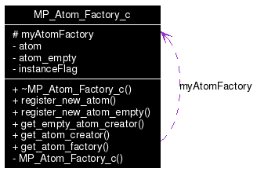
Class methods specification
Getter for atom factory singleton:
Method to get an unique instance of MP_Atom_Factory_c.
MP_Atom_Factory_c * MP_Atom_Factory_c::get_atom_factory ( ) [static]

Getter for Factory Method empty atom creator :

Accesor method to obtain the adress of a function to create empty atom.

MP_Atom_c*(* MP_Atom_Factory_c::get_empty_atom_creator (const char * atomName)

Parameters:
atomName,: name of the atom to create
Returns:
a pointer on a method able to create an empty atom

Getter for Factory Method file atom creator :

Accesor method to obtain the adress of a function to create an atom from a file.

MP_Atom_c*(* MP_Atom_Factory_c::get_atom_creator (const char * atomName)

Parameters:
atomName,: name of the atom to create
Returns:
a pointer on a method able to create an atom from a file

Method to register new atom in the factory:
Method to register a new method to create atom from file.

void MP_Atom_Factory_c::register_new_atom (const char * atomName, MP_Atom_c *(*)(FILE *fid, const char mode) createAtomFunctionPointer)

Parameters:
atomName,: name of the atom to register
createAtomFunctionPointer,: a pointer on the function used to create an atom from a file
Method to register new atom in the factory:
Method to register a new method to create empty atom

void MP_Atom_Factory_c::register_new_atom_empty (const char * atomName, MP_Atom_c *(*)(void) createEmptyAtomFunctionPointer)

Parameters:
atomName,: name of the atom to register
createEmptyAtomFunctionPointer,: a pointer on the function used to create an empty atom

Class data
Hash map to store the atom name and the file creation atom method pointer
hash_map<const char*, MP_Atom_c*(*)(FILE *fid, const char mode), hash<const char*>, eqstr> atom;
Hash map to store the atom name and the empty atom method pointer
hash_map<const char*, MP_Atom_c*(*)(void), hash<const char*>, eqstr> atom_empty;

- Concrete implementation: compile and link your plug-in
A template class for both atoms and blocks is available, if you made a checkout of the SVN trunk (what you may have done in order to have the latest version of MPTK sources files).
The template files are located in directory src/plugin/contrib/template :
src/plugin/contrib/template/template_atom_plugin.h
src/plugin/contrib/template/template_block_plugin.h
src/plugin/contrib/template/template_atom_plugin.cpp
src/plugin/contrib/template/template_block_plugin.cpp
This files have the same structure than the standard atoms/blocks plug-in source files, they have just be cleaned in order to simplify the understanding.
in order to compile and link your plug-in, you will need to modify the
CMake file located in src/plugin/CMakeLists.txt
The data to modify are located at the end of the file:
##EXAMPLE FOR BUILD YOUR OWN ATOMS AND BLOCKS:
##JUST REPLACE TEMPLATE BY THE NAME OF YOUR BLOCKS/ATOMS AND ##UNCOMMENT
#########################################
#Create the Constant Atom plugin in DLL
#SET(TEMPLATE_ATOM_PLUGIN_SOURCES
#contrib/template/template_atom_plugin.h
#contrib/template/template_atom_plugin.cpp)
#ADD_CUSTOM_TARGET(templateatom-lib DEPENDS ${TEMPLATE_ATOM_PLUGIN_SOURCES})
#ADD_LIBRARY(templateatom SHARED ${TEMPLATE_ATOM_PLUGIN_SOURCES})
# SET_TARGET_PROPERTIES(constantatom PROPERTIES
# COMPILE_FLAGS " -DC_BUILDING_TEMPLATEATOM ${SHARED_FLAGS} -Wno-deprecated"
# PREFIX ""
# OUTPUT_NAME "TemplateAtom")
#TARGET_LINK_LIBRARIES(templateatom mptk)
#ADD_DEPENDENCIES(templateatom templateatom-lib)
#IF(BUILD_SHARED_LIBS)
#INSTALL(TARGETS
# templateatom
# LIBRARY DESTINATION lib
# ARCHIVE DESTINATION lib)
#ENDIF(BUILD_SHARED_LIBS)
#########################################
#Create the template block plugin in DLL
#SET(TEMPLATE_BLOCK_PLUGIN_SOURCES
#contrib/template/template_block_plugin.h
#contrib/template/template_block_plugin.cpp)
#ADD_CUSTOM_TARGET(templateblock-lib DEPENDS ${TEMPLATE_BLOCK_PLUGIN_SOURCES})
#ADD_LIBRARY(templateblock SHARED ${TEMPLATE_BLOCK_PLUGIN_SOURCES})
# SET_TARGET_PROPERTIES(templateblock PROPERTIES
# COMPILE_FLAGS " -DC_BUILDING_TEMPLATEBLOCK ${SHARED_FLAGS}-Wno-deprecated"
# PREFIX ""
# OUTPUT_NAME "TemplateBlock")
#TARGET_LINK_LIBRARIES(templateblock mptk)
#ADD_DEPENDENCIES(templateblock templateblock-lib)
#IF(BUILD_SHARED_LIBS)
#INSTALL(TARGETS
# templateblock
# LIBRARY DESTINATION lib
# ARCHIVE DESTINATION lib)
You are suggested to create a new directory in the contribution directory, name it as you wish and put your source code files into it.
You will have to change the name and path of the source files and the name of target and library in this part of the CMake file, in case of doubt, just watch upper in the CMake file to understand how it works with another examples of naming for other atoms/blocks pair still implemented.
- Help, contact and forums
If you need help with the software:
- check if a more recent release fixes your problem;
- if not, use the Help forum to ask questions.

Other Forums are available for open discussions about the Matching Pursuit algorithm and its MPTK implementation.
Some articles exposing scientific results related to MPTK are available in PDF format through the Released Files page.

If you want specific informations, or if you want to communicate privately with us, please write to
matching.pursuit@irisa.fr.

Request for help sent to this address won't be answered. Please use the Help forum instead.

Thank you for your interest in The Matching Pursuit ToolKit !
- Credits
- http://yallara.cs.rmit.edu.au/~aholkner/dynload/index.html
- http://www.jdkoftinoff.com/main/Articles/Linux_Articles/ELF_Plugins/index.php
- http://www.codeguru.com/cpp/misc/misc/plug-insadd-ins/article.php/c3879/
- http://postmodernprogramming.blogspot.com/2006/09/plugins-dynamically-loadable-classes.html
- http://www.codeproject.com/useritems/plat_ind_coding.asp
- http://www.isotton.com/howtos/C++-dlopen-mini-HOWTO/C++-dlopen-mini-HOWTO.html

